

*java iot developer Lab*

Lab -3

**SUBMITTED BY: SUBMITTED TO:**

**AYUSH KUMAR JHA Dr. SURBHI SARASWAT**

**SAP ID - 500086400**

**Enrollment no - R200220083**

**B.C.A -I.O.T.**

Questions :-

1. Write a program that creates a Graphical user interface using JAVA AWT to input the choices of a user. Create a text box where the user can enter his name. Then Create a Checkbox group with three fruits and a dropdown list with three vegetables. Finally display the section by the user.

For example: User1 has selected grapes and tomatoes.

Syntax.

package Asssignment_3;  
 import javax.swing.*;  
 import java.awt.*;  
 import java.awt.event.ActionEvent;  
 import java.awt.event.ActionListener;  
  
public class First {  
 First(){  
 JFrame f =new JFrame("Question no. 1");  
 String result ;  
 JButton b=new JButton("Submit ");  
 b.setBounds(400,400,80,30);// setting button position  
  
 TextField textField = new TextField("Enter your name here");  
 textField.setBounds(100,50,250,20);  
  
 CheckboxGroup obj = new CheckboxGroup();  
 Checkbox ckbox1 = new Checkbox("Apple",obj, true);  
 ckbox1.setBounds(100,100, 60,60);  
 Checkbox ckbox2 = new Checkbox("Banana",obj,false);  
 ckbox2.setBounds(100,150, 60,60);  
 Checkbox ckbox3 = new Checkbox("Orange ",obj,false);  
 ckbox3.setBounds(100,200, 60,60);  
  
 List list=new List(3,false);  
 list.setBounds(300,250, 100,50);  
 list.add("broccoli");  
 list.add("Potatoes");  
 list.add("Tomatoes");  
  
 f.setDefaultCloseOperation(f.*EXIT_ON_CLOSE*);  
 f.add(textField);  
 f.add(ckbox1);  
 f.add(ckbox2);  
 f.add(ckbox3);  
 f.add(list);  
 f.add(b);//adding button into frame  
  
 f.setSize(500,500);  
// f.setLayout(new FlowLayout());  
 f.setVisible(true);  
  
// .addItemListener(this);  
 b.addActionListener(new ActionListener(){  
 public void actionPerformed(ActionEvent e){  
 textField.setBounds(100,50,200,20);  
 String name = textField.getText();  
 if(ckbox1.getState()){  
 if (list.isIndexSelected(0)){  
 textField.setText(name+" has selected Apple and broccoli.");  
 }else if (list.isIndexSelected(1)){  
 textField.setText(name+" has selected Apple and Potatoes.");  
 }else if (list.isIndexSelected(2)){  
 textField.setText(name+" has selected Apple and Tomatoes.");  
 }  
 }  
 else if (ckbox2.getState()){  
 if (list.isIndexSelected(0)){  
 textField.setText(name+" has selected Banana and broccoli.");  
 }else if (list.isIndexSelected(1)){  
 textField.setText(name+" has selected Banana and Potatoes.");  
 }else if (list.isIndexSelected(2)){  
 textField.setText(name+" has selected Banana and Tomatoes.");  
 }  
 }else if (ckbox3.getState()){  
 if (list.isIndexSelected(0)){  
 textField.setText(name+" has selected Orange and broccoli.");  
 }else if (list.isIndexSelected(1)){  
 textField.setText(name+" has selected Orange and Potatoes.");  
 }else if (list.isIndexSelected(2)){  
 textField.setText(name+" has selected Orange and Tomatoes");  
 }  
 }  
 list.setVisible(false);  
 ckbox1.setVisible(false);  
 ckbox2.setVisible(false);  
 ckbox3.setVisible(false);  
 b.setVisible(false);  
  
 }  
 });  
  
 }  
  
 public static void main(String args[]){  
 First f=new First();  
 }  
}

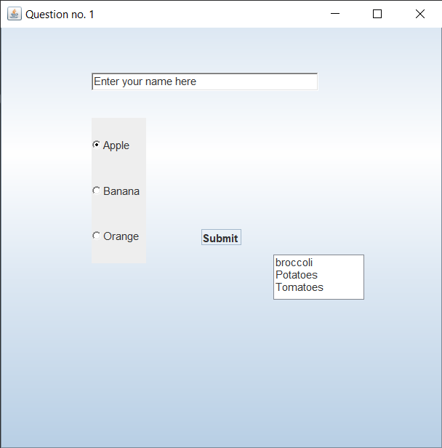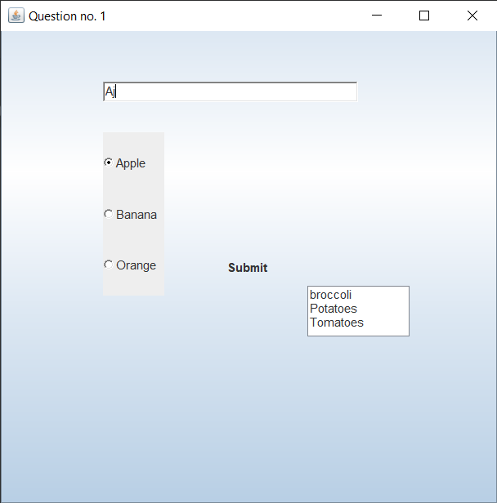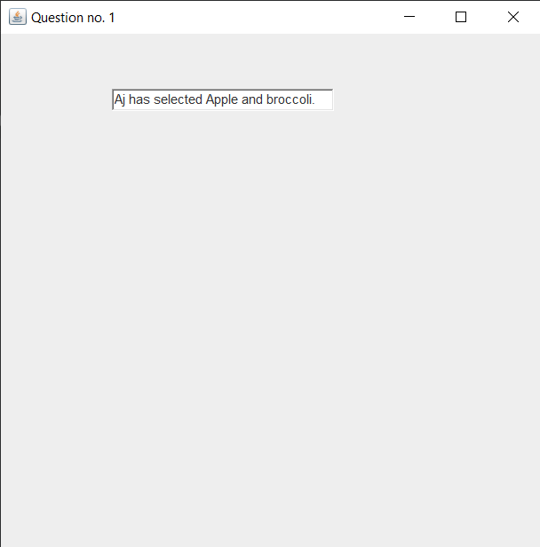

2. Create a GUI counter using JAVA AWT.

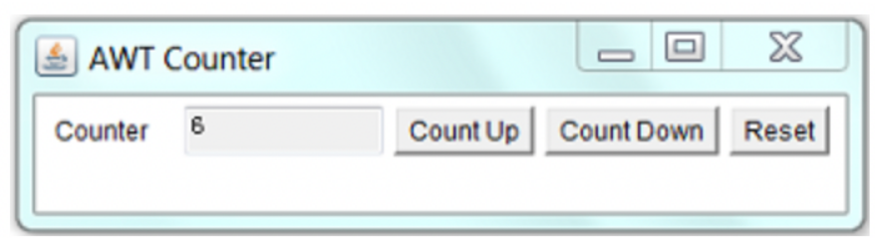

package Asssignment_3;  
  
import javax.swing.*;  
import java.awt.*;  
import java.awt.event.ActionEvent;  
import java.awt.event.ActionListener;  
  
public class Second {  
 Second() {  
  
 JFrame jf = new JFrame("AWT Counter");  
 JLabel entry = new JLabel("Counter ");  
 jf.setLayout(new FlowLayout());  
  
 JFormattedTextField jT = new JFormattedTextField("0");  
 jT.setBounds(100,100,100,30);  
  
  
 JButton b1 = new JButton("Count Up");  
 JButton b2 = new JButton("Count Down");  
 JButton b3 = new JButton("Reset");  
  
  
 jf.add(entry);  
 jf.add(jT);  
 jf.add(b1);  
 jf.add(b2);  
 jf.add(b3);  
  
 jf.setDefaultCloseOperation(jf.*EXIT_ON_CLOSE*);  
 jf.setSize(400,100);  
 jf.setVisible(true);  
 b1.addActionListener(new ActionListener() {  
 @Override  
 public void actionPerformed(ActionEvent e) {  
 int value ;  
 String val = jT.getText();  
 value = Integer.*parseInt*(val)+1;  
 jT.setText(value+"");  
  
 }  
 });b2.addActionListener(new ActionListener() {  
 @Override  
 public void actionPerformed(ActionEvent e) {  
 int value ;  
 String val = jT.getText();  
 value = Integer.*parseInt*(val)-1;  
 jT.setText(value+"");  
  
 }  
 });b3.addActionListener(new ActionListener() {  
 @Override  
 public void actionPerformed(ActionEvent e) {  
 int value= 0;  
 jT.setText(value+"");  
  
 }  
 });  
 }  
  
 public static void main(String[] args) {  
 Second sc = new Second();  
 }  
}

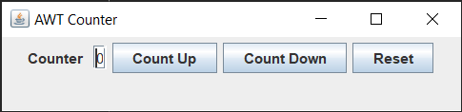

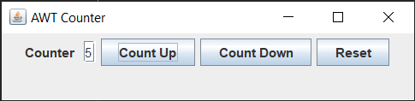

3.Write a program that creates a Graphical user interface to perform basic calculations. The user enters two numbers in the text fields, Num1 and Num2. Create a text field to display the results.

Create buttons for four operations Add, Sub, Multiply, Divide.

When the Divide button is clicked: The division of Num1 and Num2 is displayed in the Result field. If Num1 and Num2 were not integers, the program would throw a Number Format Exception. If Num2 were zero, the program would throw an Arithmetic Exception Display the exception in a message dialog box.

Use label field to display the exceptions.

Your GUI could look something like this.

package Asssignment_3;  
  
import javax.swing.*;  
import java.awt.*;  
import java.awt.event.ActionEvent;  
import java.awt.event.ActionListener;  
  
public class Third {  
 Third(){  
 JFrame jf = new JFrame("Calculator");  
  
 Label l1= new Label(" First Number ");  
// l1.setBounds(50,75,75,20);  
 Label l2 = new Label(" Second Number ");  
// l2.setBounds(50,150,75,20);  
 Label l3 = new Label(" Result ");  
// l3.setBounds(50,225,75,20);  
  
 TextField t1 = new TextField(" First value ");  
// t1.setBounds(150,75,250,20);  
 TextField t2 = new TextField("Second Value ");  
// t2.setBounds(150,150,250,20);  
 TextField t3 = new TextField(" ");  
// t3.setBounds(150,225,250,20);  
  
 Button b1 = new Button("Add");  
// b1.setBounds(5,300,20,20);  
 b1.addActionListener(new ActionListener() {  
 @Override  
 public void actionPerformed(ActionEvent e) {  
 int res ;  
 res = Integer.*parseInt*(t1.getText())+Integer.*parseInt*(t2.getText());  
  
 t3.setText(res+"");  
 }  
 });  
 Button b2 = new Button("Sub");  
// b1.setBounds(15,300,20,20);  
 b2.addActionListener(new ActionListener() {  
 @Override  
 public void actionPerformed(ActionEvent e) {  
 int res ;  
 res = Integer.*parseInt*(t1.getText())-Integer.*parseInt*(t2.getText());  
  
 t3.setText(res+"");  
 }  
 });  
  
 Button b3 = new Button("Mul");  
// b1.setBounds(25,300,20,20);  
 b3.addActionListener(new ActionListener() {  
 @Override  
 public void actionPerformed(ActionEvent e) {  
 int res ;  
 res = Integer.*parseInt*(t1.getText())*Integer.*parseInt*(t2.getText());  
  
 t3.setText(res+"");  
 }  
 });  
 Button b4 = new Button("Div");  
// b1.setBounds(30,300,20,20);  
 b4.addActionListener(new ActionListener() {  
 @Override  
 public void actionPerformed(ActionEvent e) {  
 int res ;  
 res = Integer.*parseInt*(t1.getText())/Integer.*parseInt*(t2.getText());  
  
 t3.setText(res+"");  
 }  
 });  
 Button b5 = new Button("Cancel");  
// b5.setBounds(40,300,20,20);  
 b5.addActionListener(new ActionListener() {  
 @Override  
 public void actionPerformed(ActionEvent e) {  
 t1.setText("");  
 t2.setText("");  
 t3.setText("");  
 }  
 });  
  
 jf.add(l1);  
 jf.add(t1);  
  
 jf.add(l2);  
 jf.add(t2);  
  
 jf.add(l3);  
 jf.add(t3);  
  
 jf.add(b1);  
 jf.add(b2);  
 jf.add(b3);  
 jf.add(b4);  
 jf.add(b5);  
  
 jf.setDefaultCloseOperation(jf.*EXIT_ON_CLOSE*);  
 jf.setSize(350,200);  
 jf.setVisible(true);  
 jf.setLayout(new FlowLayout());  
  
  
 }  
  
 public static void main(String[] args) {  
 Third t = new Third();  
 }  
  
}

